****Resume****

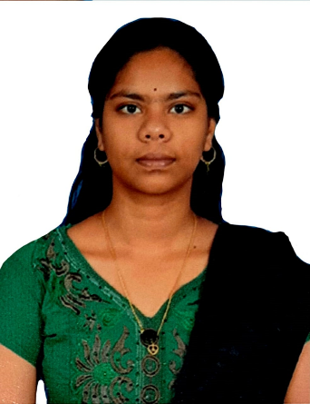

****Selva Bharathi S****

* Phone : 08838546085
* Email : sowmyaselvam461@gmail.com
* Address : No.34, Krishnasaamy nagar,

salakarai road , Chellankuppam , Cuddalore, 607003.

**Academic Qualifications**

|  |  |  |  |  |  |  |  |  |
| --- | --- | --- | --- | --- | --- | --- | --- | --- |
| |  | | --- | | **Degree/ Certificate** | | |  |  |  | | --- | --- | --- | | **Institute** |  |  | | **Board/**  **University** | **Year** | **CGPA / %** |
| |  | | --- | | **MCA** | | |  | | --- | | PSG College of Technology,  Coimbatore | | |  | | --- | | Anna University | | |  | | --- | | 2019-2022 | | |  | | --- | | 8.22* | |
| |  | | --- | | **BCA** | | |  | | --- | | St. Joseph’s College of Arts and Science(Autonomous) - Cuddalore | | Thiruvalluvar  University | 2016-2019 | 8.5 |
| |  | | --- | | **XII** | | |  | | --- | | St. Annes Girls Higher Secondary School –Cuddalore | | |  | | --- | | State Board | | 2016 | 84% |
| |  | | --- | | **X** | | St. Phillomina’s Girls High School –Cuddalore | |  | | --- | | State Board | | 2013 | 92.2% |